Sustainability Department
Estates Services

Ultra-Low Temperature (ULT) Freezer Maintenance
Quick Reference Guide

ULT freezers are expensive items of equipment to maintain, run and replace. To ensure that costs remain low and the contents remain safe follow the guidance below.

Allocate a freezer manager and report any issues with the freezer to them as soon as possible
Allocating a freezer manager means problems with the freezer are managed efficiently and freezers are less likely to go into disrepair.

Use a clear inventory system to reduce open door time
Opening freezer doors introduces moisture into the freezer which then frosts up the unit. If the unit gets too frosted it can be difficult to remove samples and close the door. Eventually the seals will become iced and damaged and the unit will struggle to remain at temperature. This can put your samples at risk and replacement of seals can be expensive (over £700 in some cases).

Label samples with an expiry date
ULT freezers add considerable operational costs to a department and each additional freezer is competing for valuable space. By maintaining a clear exit policy and clearing out unused and unnecessary samples you reduce the need for additional units.

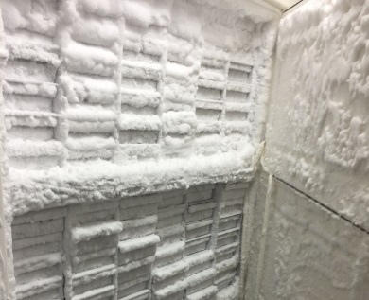
Clear ice away regularly
Clear away any ice build-up with a soft cloth, dustpan and brush, or rubber mallet. Avoid using sharp tools and be cautious to avoid damaging the rubber seals and gaskets. As frost builds up on the evaporator coils the heat transfer rate in the freezer cabinet is decreased due to the insulating effects of ice. This means the compressor has to work harder and longer to maintain cool temperatures, wasting more energy. Removing the ice regularly can also extend freezer life.

Use box racking
Using solid boxes rather that wire mesh containers helps retain cold air in the unit when the door is opened. This helps maintain a more constant temperature for samples. You will also require less metal in the racking, making it more affordable.

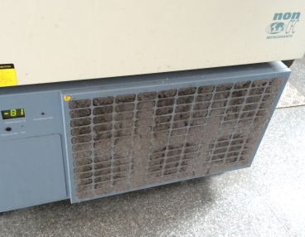
Clean filters regularly
The filter is where the freezer removes its hot air and ‘breathes’. Dirty filters mean the compressor has to work harder. Working a compressor harder increases energy consumption and cost to the department. It also increases the risk of early failure. This not only increases maintenance costs but also puts samples at risk when the freezer does fail.

ULT freezers should ideally be kept in dedicated freezer rooms
Additional heat from freezers increases the ventilation and cooling loads in a room. Where building systems are able to cope with additional load this increases the running costs and where systems cannot cope it creates an uncomfortable environmental for building users. Freezers that operate in warm environments work harder therefore increasing running costs and increasing risk of failure and therefore risk to samples.

Keep emergency freezers at -60°C
A freezer at -60°C may take 1-2 hours to cool down to minus 70°C. Keep space in the unit occupied using boxes or spare racking, then swap in your samples as of when required. By doing this you will reduce frosting and the energy consumption of your back-up freezer. In the event of a freezer failure, having racking will help hold the internal temperature for longer. Until you are prepared to load your samples into the back-up freezer, do not open the door.

Unless specifically required freezers should be set at -70°C
Only cool samples to the temperature that is absolutely needed. In the majority of cases, samples can be safely stored at -70°C rather than -80°C. A study done by the University of Harvard demonstrates that antibodies, antigens and nucleic acids can be stably stored for at least 20 years at a temperature of -70˚C.
By increasing the set temperature from -80˚C to -70˚C you can reduce the energy consumption of your freezer by ~28% and preserve the compressors.

Be clutter free; do not stack boxes against or on top of the units
Blocking vents and storing items around the units can increase the risk of the unit failure by increasing the work load on the compressor. ULTs should be at least 15cm away from the wall.

Replace old freezers to reduce running and maintenance costs
A freezer replacement grant is available from the Sustainability team. Find out more on the Sustainability website (www.bris.ac.uk/green/get-involved/sustainable-labs). An old inefficient freezer can cost >£1,000 per annum in electricity, compared to <£300 for an Eppendorf Cryocube F570h.

Replace damaged seals as soon as possible
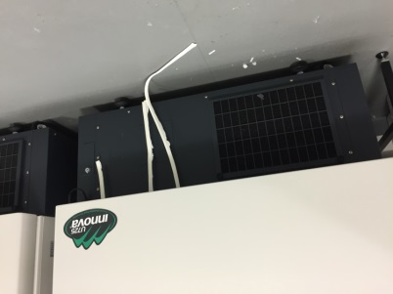
A damaged seal allows air into the unit which raises its temperature; this means the unit has to work harder to retain a stable temperature. It is likely to frost and then ice up and will be prone to early failure due to the compressor working harder.

Contact us
E-mail: anna.lewis@bristol.ac.uk Tel: 011733 17110

